Analysis to find if more guns reduce crime

using STATA



**Objective:**

“The only way to stop a bad guy with a gun is with a good guy with a gun,” [said](http://washington.cbslocal.com/2012/12/21/nra-only-way-to-stop-a-bad-guy-with-a-gun-is-with-a-good-guy-with-a-gun/) Wayne LaPierre, vice president of the National Rifle Association (NRA), after a gunman killed 20 children and six others at Sandy Hook Elementary School in December 2012.

Many strongly believe that state laws enabling citizens to carry concealed handguns had reduced crime. According to this view, gun control laws take away guns from law-abiding citizens, while would-be criminals ignore those leaving potential victims defenseless.

Following this view, The National Rifle Association (NRA) and many politicians across the country advance the cause of greater freedom to carry guns. As a result, many states in the United States have passed right-to-carry laws (also known as a shall-issue laws). A Shall-issue law is one that requires that governments issue concealed carry handgun permits to any applicant who meets the necessary criteria. These criteria are: the applicant must be an adult, have no significant criminal record, and no history of mental illness and successfully complete a course in firearms safety training (if required by law). If these criteria are met, the granting authority has no discretion in the awarding of the licenses, and there is no requirement of the applicant to demonstrate "good cause".

Here we are considering the shall to be the dependent variable that is regressed on all the independent variables that could affect the crime rate. The regression is compared over different models to find the best suitable model.

We use the economic theory and economic models to analyze the data and to estimate the crime rate value and the changes in it. From the data present for the years 1977 to 1999, we try to analyze each factor to decide which factor to include in our model. We consider all the relevant factors that could influence the crime rate.

**Descriptive Statistics:**

The data we used in this project is guns data (guns.dta) which is a panel data of 50 states in US and also the District of Columbia making a total of 51 states in the years 1977 – 1999. These states are given a unique code i.e. state ID where every state is given a ID. After examining the data, we noticed that there were states missing with the state’s codes ‘3’, ‘4’, ‘14’ and ‘43’. After further research we identified that these state IDs do not exist. Otherwise, there are no missing values in the data.

By further description of variables, we noticed that *vio, incarc_rate* and *density* are positively skewed. Hence, we considered taking natural logs for these variables.

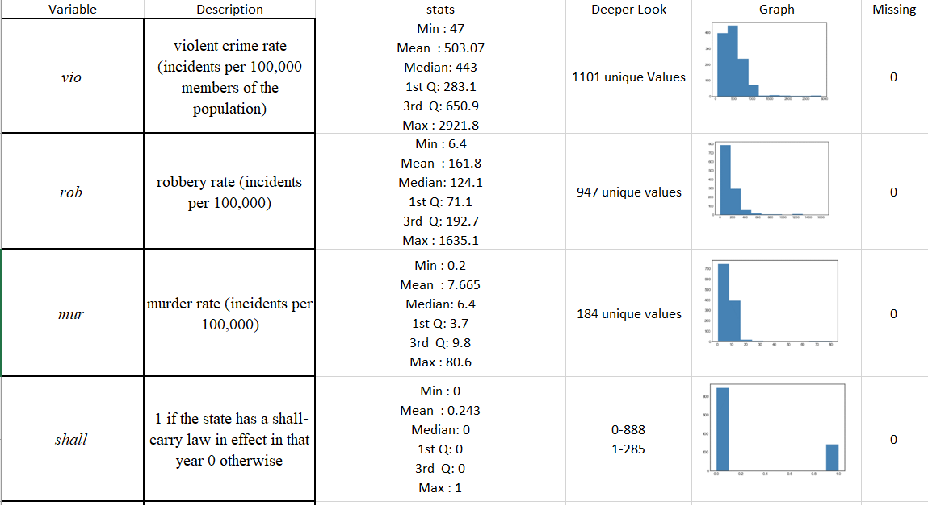

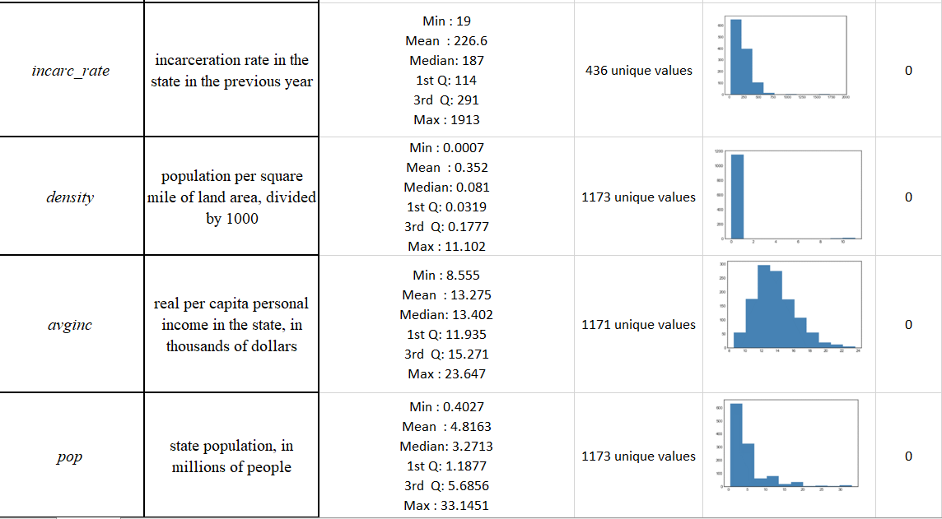

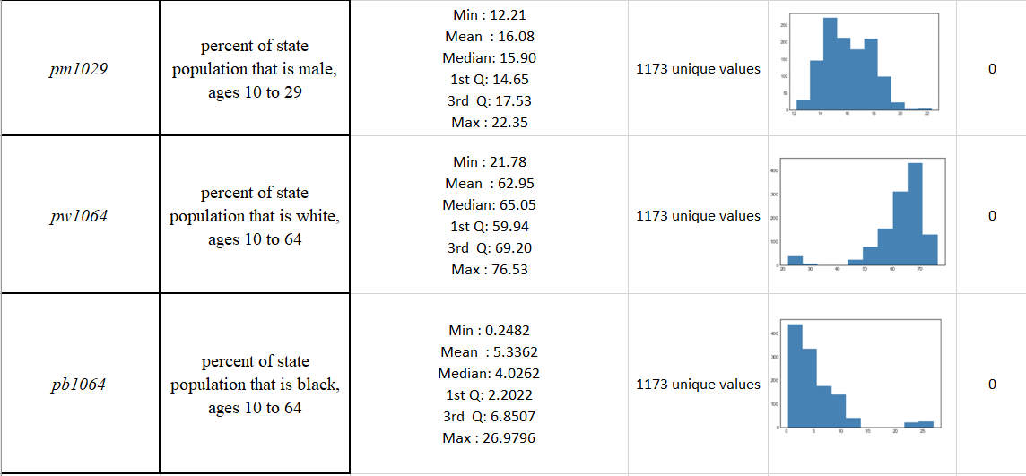

**Data Analysis:**

To understand the impact of using handguns on crime rates, we check for the different variables and the effects these have in different regions on the crime rate.

**Distribution of violent crime rate in US**

Below is the map showing the crime rates across different states in the US. We find that Florida (FL) has the highest violent crime rate per 100,000 people living in that state.

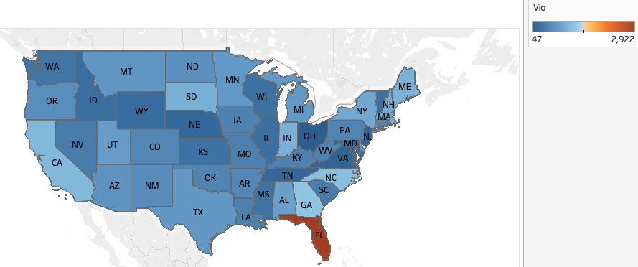

**Figure: Average violent crime rate for different states**

**Effect of Shall Law Vs No Shall Law:**

By plotting the graph of shall effect (1= Shall carry law, 0= No shall carry law) across crime rate, robbery rate and murder rate we find that the violent crime rate is the most effected with the implementation of the shall law. The crime rate is very large without shall law compared to the crime rate after implementation of shall law.

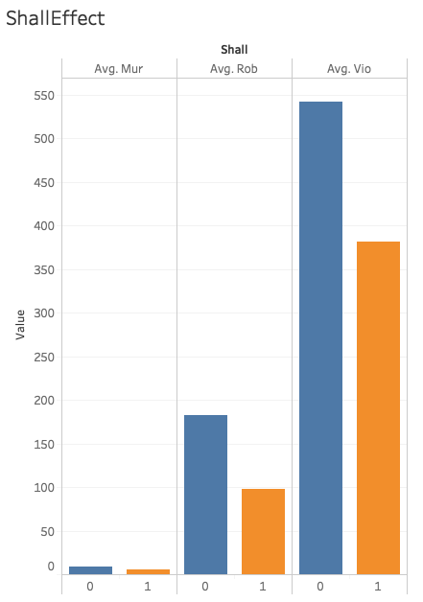

**Figure: Average crime rate Vs Shall law**

**Change in crime rate from 1977-1999 vs Shall law:**

Here we plot a trend line between violent crime rate, murder rate and robbery rate based on shall law to see if carrying a gun has an impact on crime rate. From the graph we can see that carrying a gun has reduced the crime by almost 40%. From this we conclude that implementation of shall law has a significant impact in reducing the crime.

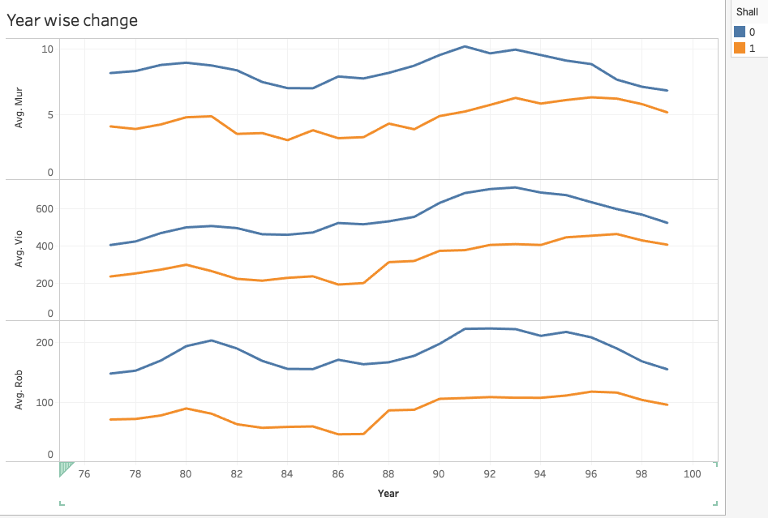

**Figure: Change in average crime rate over 1977-1999**

**Violent Crime Rate Vs Incarceration Rate:**

The graph below shows that violent crime rate(ln(vio)) is highly increasing with the increase in incarceration rate (ln(incarc_rate)) This means, incarceration rate has positive effect on the violent crime rate.

According to economic theory, it is expected that as incarceration rate increases violent rate should decrease but in our case, we can see a positive relationship between the two. This could indicate the presence of simultaneous causality bias

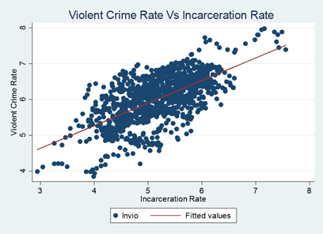

**Violent Crime Rate Vs Population Density:**

The below graph shows the relation between violence crime rate (ln(vio)) and density per sq. mile divided by 1000 (ln(density)). We notice that there is a positive relation between the variables which suggests that there is a high crime rate where density of the population is moderate

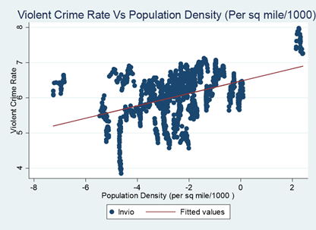

**Violent crime rate Vs Average Income:**

In the below graph crime rate is represented based on per capita personal income in the state (in thousands of dollars) i.e. average income. Here we can see that most of the states have average income in the range 10k to 15k. The crime rate in these states is also high. States with higher average income tend to have lesser crime rate. But some states with higher average income have higher crime rate. This says people with higher income in these states are at risk.

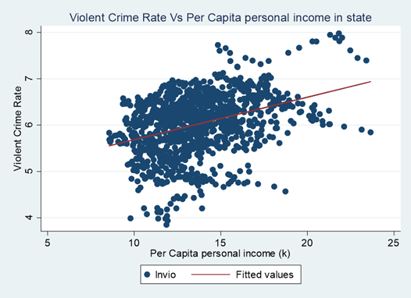

**Violent crime rate Vs Population:**

In the below graph, violent crime rate (ln(vio)) is plotted against population. Here population is in millions. From the graph we can see that crime rate increases with population. We can also see that in few states even though population is less, crime rate is high. This could be because there is more probability to attack people when there is less crowd than in places which are highly populated.

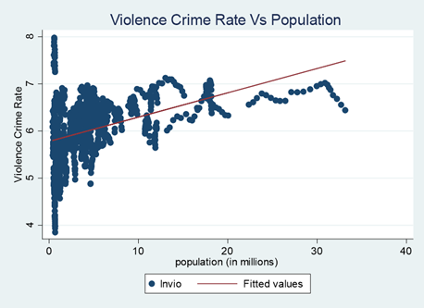

**Violent Crime Rate Vs Male Population:**

The below graph gives a relation between violent crime rate (ln(vio)) and percent of male population between the age group 10- 29 (pm1029). We notice a slight negative relation between the two variables and a lesser correlation between them which suggests that the areas with male population of 10- 29 years is not possessing high crime rate.

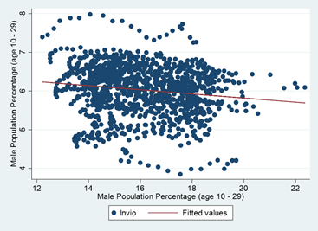

**Violent crime rate Vs White Population:**

In the below graph, crime rate is measured as the percentage of black population in a state in the age group 10 – 64. We can see that crime rate decreases as the percentage of white population increases. We can also see that most of the states have a good percentage of whites.

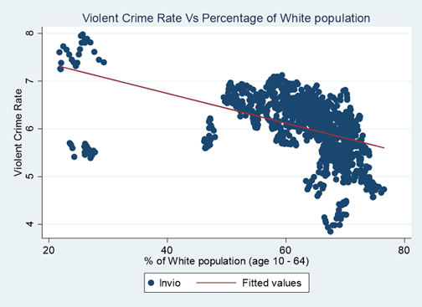

**Violent crime rate Vs Black Population:**

In the below graph, crime rate is measured as the percentage of black population in a state in the age group 10 – 64. Here we see that crime rate increases as the percentage of black population in a state increase. There is a higher crime rate in states with higher percent of black population which contrasts with what we see in the previous graph where increase in percent of white population decreases the crime rate. Also, number of black people are very less compared to number of white people. Economic theory suggests black people tend to have lower wages compared to white people and hence they are more prone to crimes due to less safety.

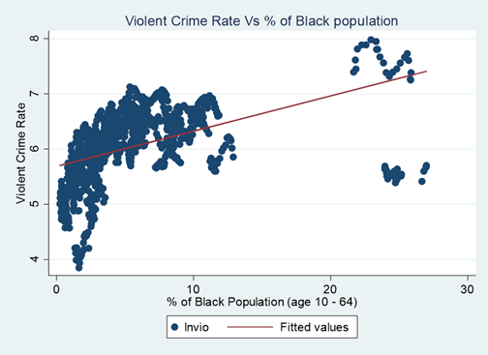

**Hypothesis Testing on Shall Law**

**1. Analysis of average violent crime rates in the states with shall-carry law and the states without shall-carry law using T-test:**

**H0**: There exists no significance difference in the average violent crime rates between the states with shall-carry law and the states without shall-carry law.

**H1**: There exists a Significant difference in the average violent crime rates between the states with shall-carry law and the states without shall-carry law.

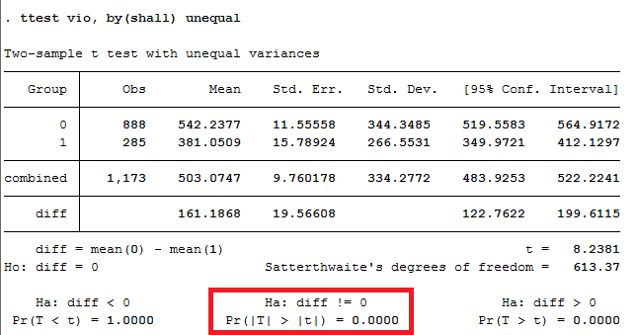

As P-value is less than 0.05, the null is rejected. It can be concluded that there exists a significance difference in the average violent crime rates between the states with shall-carry law and the states without shall-carry law.

**2. Analysis of average murder rates in the states with shall-carry law and the states without shall-carry law using T-test:**

**H0**: There exists no significance difference in the average murder rates between the states with shall-carry law and the states without shall-carry law.

**H1**: There exists a Significant difference in the average murder rates between the states with shall-carry law and the states without shall-carry law.

As P-value is less than 0.05, the null is rejected. It can be concluded that there exists a significance difference in the average murder rates between the states with shall-carry law and the states without shall-carry law.

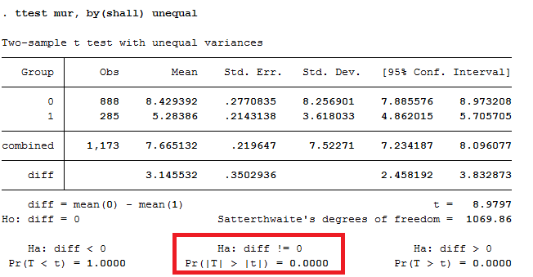

**3. Analysis of average Robbery rates in the states with shall-carry law and the states without shall-carry law using T-test:**

**H0**: There exists no significance difference in the average robbery rates between the states with shall-carry law and the states without shall-carry law.

**H1**: There exists a Significant difference in the average robbery rates between the states with shall-carry law and the states without shall-carry law.

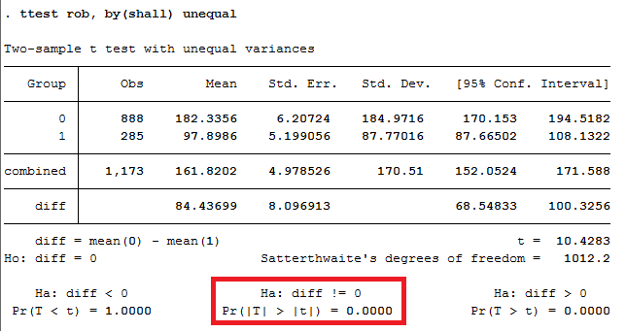

As P-value is less than 0.05, the null is rejected. It can be concluded that there exists a significance difference in the average robbery rates between the states with shall-carry law and the states without shall-carry law.

**4. Analysis of average incarceration rates in the states with shall-carry law and the states without shall-carry law using T-test:**

**H0**: There exists no significance difference in the average incarceration rates between the states with shall-carry law and the states without shall-carry law.

**H1**: There exists a Significant difference in the average incarceration rates between the states with shall-carry law and the states without shall-carry law.

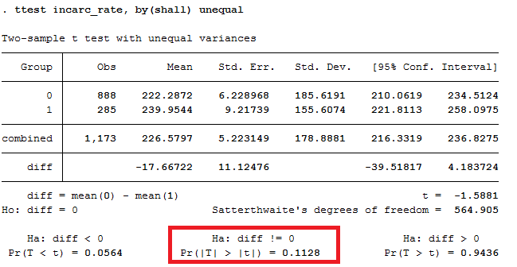

As P-value is greater than 0.05, the null cannot be rejected. It can be concluded that there exists no significance difference in the average robbery rates between the states with shall-carry law and the states without shall-carry law.

**Regression Analysis**

**Skewed variables:**

The histogram plots of violent crime rate, incarceration rate, density, murder rate and robbery rate are right skewed, hence we transformed these variables using logarithmic function.

**Correlation matrix:**

* Robbery rate is highly correlated to violent crime rate and murder rate is also highly correlated to violent crime rate.
* pb1064 and pw1064 are highly negatively correlated (-0.98). Including independent variables that are highly correlated can lead to inflated Standard Errors

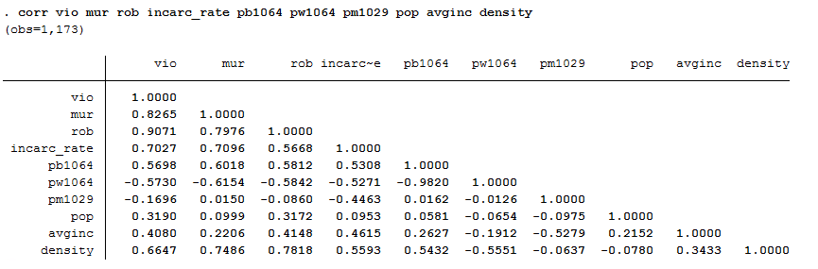

**Heteroskedasticity:**

Below is the residual plot of lincarc_rate. Though it’s not clear from the plot, we assume the presence of Heteroskedasticity. Hence, we use cluster robust standard errors

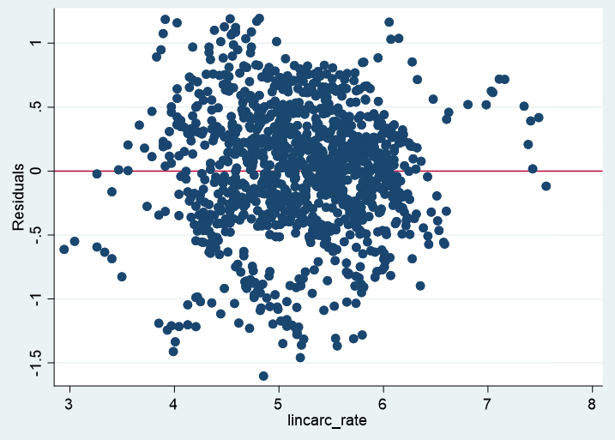

**Pooled OLS model:**

Ignoring the panel nature of the data change in crime rate across different states was checked by using pooled OLS regression.

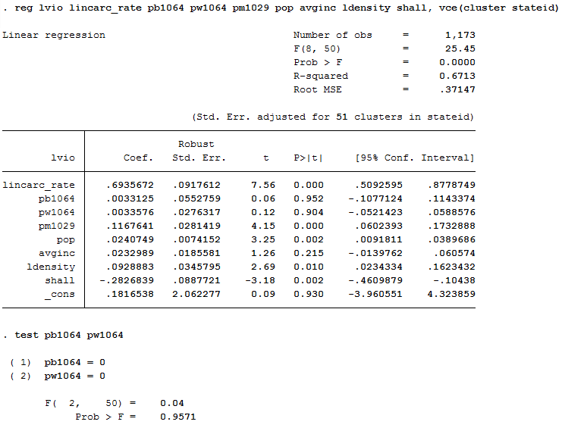

* The states with shall-law have approximately 28.27% less violent crime rate than the states without shall-law. Estimates of pb1064 and pw1064 are not significantly different from zero.
* For 1% increase in incarc_rate the violent crime rate increases by 69.35%.
* For every 1 unit increase in pm1029 the violent crime rate increases by 11.67%.
* For every 1 unit increase in pop the violent crime rate increases by 2.4%.
* For every 1 unit increase in avginc the the violent crime rate increases by 2.3%.
* For 1% increase in ldensity the violent crime rate increases by 9.2%.

**Fixed Effects model with entity fixed:**

To check the within effects, I performed the Fixed Effects Panel Regression. Fixed Effects model does a great job in capturing the unobserved heterogeneity which Pooled OLS failed to do so.

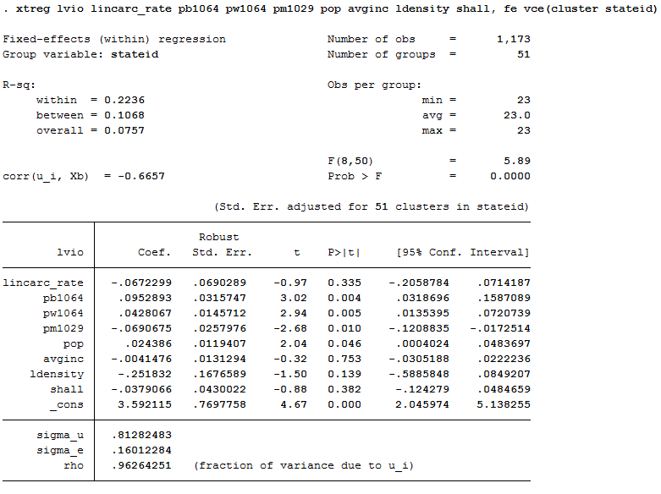

* The states with shall-law have approximately 3.79% less violent crime rate than the states without shall-law. The estimate has fallen drastically and the variable has become insignificant.
* The variable lincarc_rate has become insignificant. The variables pb1064 and pw1064 have become significant.

**Random Effects model:**

To observe both within and between effects, I performed the Random Effects Panel Regression.

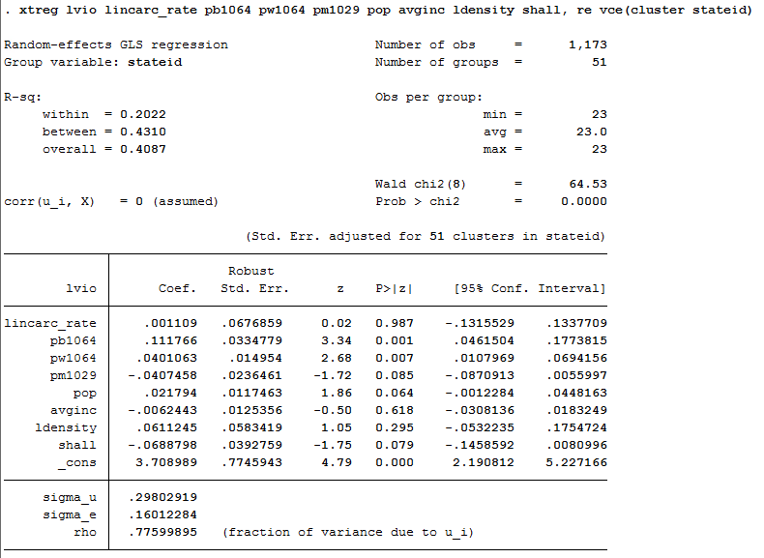

The states with shall-law have approximately 6.88% less violent crime rate than the states without shall-law. The variable has become significant at 10% level of significance.

**Hausman Test:**

This test compares the coefficient estimates from the Random Effects model to those from the Fixed Effects model.

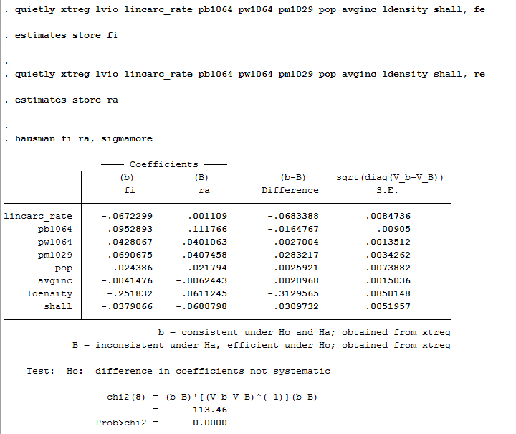

From the above Chi-square and P-value, we will have to reject the Null Hypothesis of no endogeneity and conclude that the Fixed Effects model is a better model for this analysis.

**Fixed effects with time and entity fixed:**

In order to observe the Shall law effect on the crime rate over the years, I performed Time Fixed Effects Panel Regression.

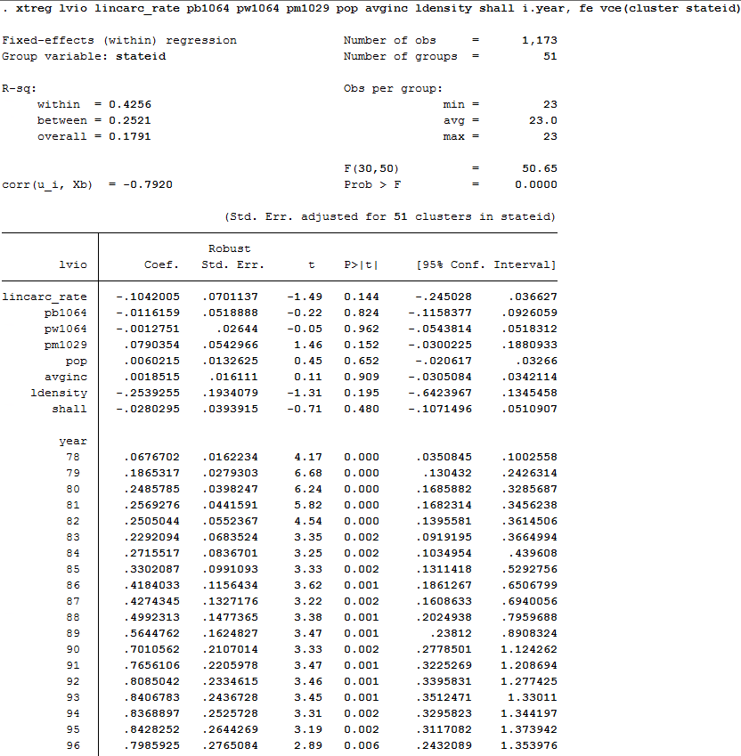

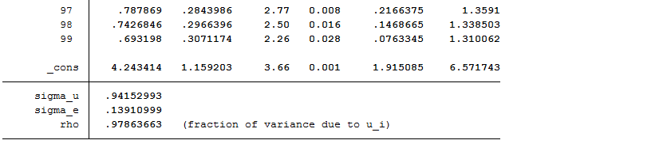

* The states with shall-law have approximately 2.8% less violent crime rate than the states without shall-law. It’s not significant.
* From 1983-1995 shows a major trend with an increase in the magnitude of the coefficients. And after 1996 we see a drop till 1999.
* Furthermore, to check if there is any trend effect, I performed a hypothesis test with H0 as Year78=year79=year80………=year99=0. This hypothesis test checks for the joint significance of year.

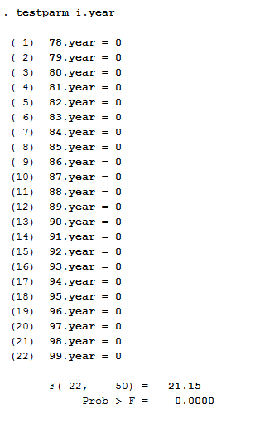

* The F-stat value obtained is 21.15 and the P-value is very low. We can now reject the null hypothesis and conclude that there is a time effect.
* We can conclude that time & entity fixed effect is the most credible model as it considers both the time and entity effects to estimate the significance of shall law on crime rate.

Further analyzing the effect of shall-law, I modelled the murder and the robbery rate using the Fixed Effects with entity and time fixed.

**Fixed Effect model with entity and time fixed on Murder rate:**

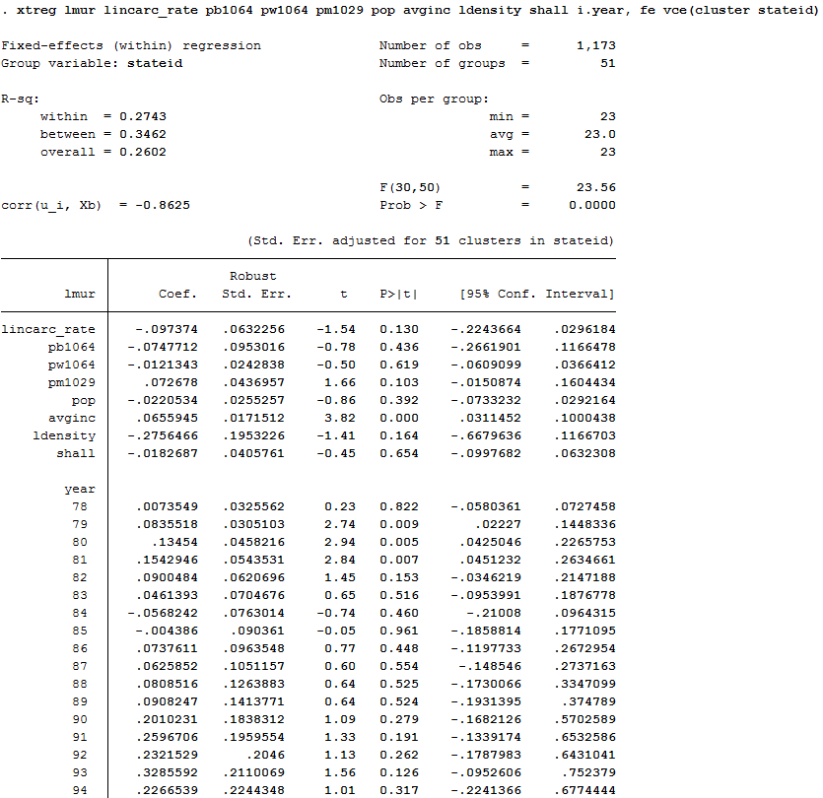

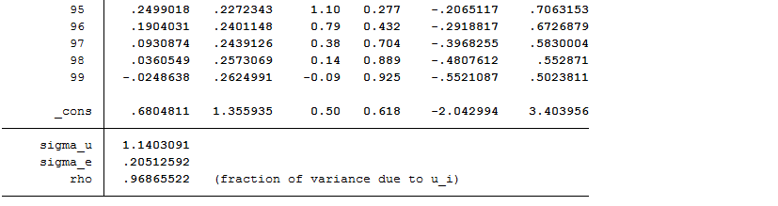

The states with shall-law have approximately 1.82% less murder rate than the states without shall-law. The variable is not significant.

**Fixed Effect model with entity and time fixed on Robbery rate:**

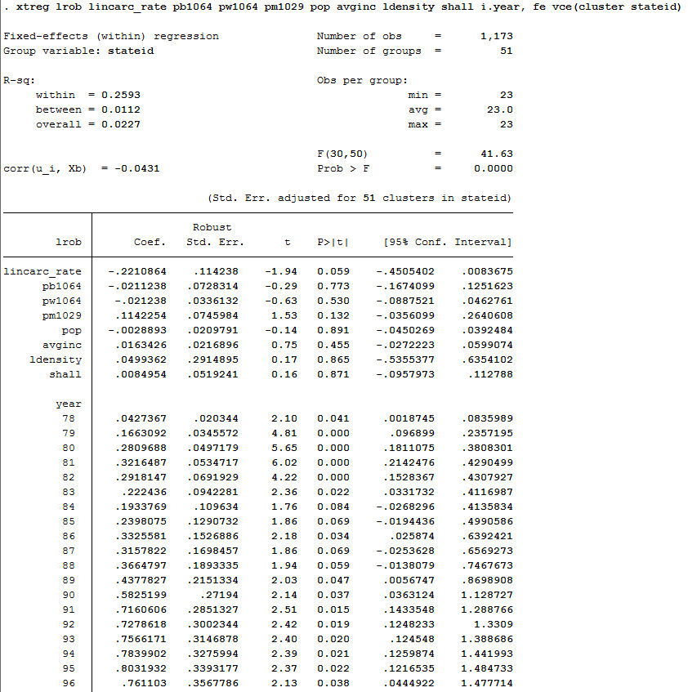

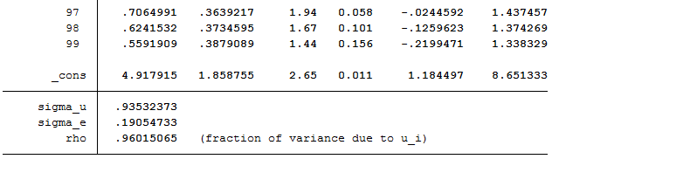

* The states with shall-law have approximately 0.85% less robbery rate than the states without shall-law. The variable is not significant. The variable is not significant.

**Conclusion:**

* From the best model (time & entity fixed effect model) I saw that implementation of shall law reduces the crime rate by just 2.8% and is insignificant.
* These results indicate that there is no significant effect of concealed weapon laws on the violent crime rate, the robbery rate nor on the murder rate.

Stata code

*Generating log variable*

generate lvio=ln(vio)

generate lincarc_rate=ln(incarc_rate)

generate ldensity=ln(density)

generate lmur=ln(mur)

generate lrob=ln(rob)

*Hypothesis testing on shall law*

ttest vio, by(shall) unequal

ttest mur, by(shall) unequal

ttest rob, by(shall) unequal

ttest incarc_rate, by(shall) unequal

*Histogram plot*

histogram vio

histogram incarc_rate

histogram density

histogram mur

histogram rob

*Correlation matrix*

corr vio mur rob incarc_rate pb1064 pw1064 pm1029 pop avginc density

*Residual plot for lincarc_rate*

reg lvio lincarc_rate

predict ehat, res

graph twoway scatter ehat lincarc_rate, yline(0)

*Pooled OLS*

reg lvio lincarc_rate pb1064 pw1064 pm1029 pop avginc ldensity shall, vce(cluster stateid)

test pb1064 pw1064

*Fixed Effects model*

xtset stateid year

xtreg lvio lincarc_rate pb1064 pw1064 pm1029 pop avginc ldensity shall, fe vce(cluster stateid)

*Random Effects model*

xtset stateid year

xtreg lvio lincarc_rate pb1064 pw1064 pm1029 pop avginc ldensity shall, re vce(cluster stateid)

*Hausman Test*

quietly xtreg lvio lincarc_rate pb1064 pw1064 pm1029 pop avginc ldensity shall, fe

estimates store fi

quietly xtreg lvio lincarc_rate pb1064 pw1064 pm1029 pop avginc ldensity shall, re

estimates store ra

hausman fi ra, sigmamore

*Fixed effects with time and entity fixed*

xtset stateid year

xtreg lvio lincarc_rate pb1064 pw1064 pm1029 pop avginc ldensity shall i.year, fe vce(cluster stateid)

testparm i.year

*Fixed effect on murder rate*

xtset stateid year

xtreg lmur lincarc_rate pb1064 pw1064 pm1029 pop avginc ldensity shall i.year, fe vce(cluster stateid)

*Fixed effect on robbery rate*

xtset stateid year

xtreg lrob lincarc_rate pb1064 pw1064 pm1029 pop avginc ldensity shall i.year, fe vce(cluster stateid)